|  |
| --- |
| Photo displaying partial image of two pie charts on a canvas-textured page |
| The Enthalpy of Combustion of Alcohols  SACE:880750L |
| |  |  |  | | --- | --- | --- | | Clay Pilat SACE:880750L | 6/16/15 | Chemistry | |

**Introduction:**

Enthalpy is the amount of heat released or absorbed when a chemical reaction occurs. The enthalpy change can be measure in ΔH. There are two different types of Enthalpy reactions which can occur; exothermic and endothermic reactions. An exothermic reaction is when Energy is released, causing it to be a product of the reactant. An endothermic reaction is when Energy is where energy is absorbed and is a reactant of the reaction. Below shows Endothermic and Exothermic reactions. (Ausetute.com.au)

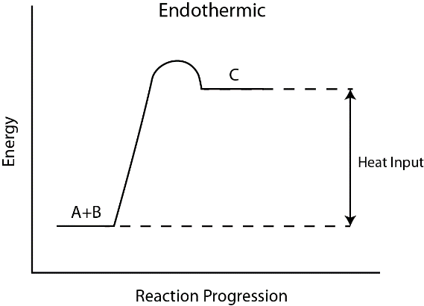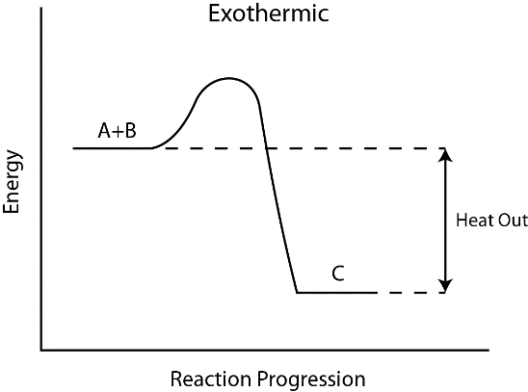

Figure 2 and 3 Reactions . (Wiki)

Alcohols are made up of oxygen, carbon and hydrogen. They belong to hydrocarbons which contain the OH group. As the number of carbon atoms increases the shape of the molecule changes. As the carbon increases the alcohol chain increases and so does the molecular mass. This creates more bonds within the molecule. The larger the amount of bonds there are the more energy it takes to break these bonds. Hence why it is stated in the hypothesis the higher the Molecular mass the more negative the Enthalpy will be. Below shows an example of the alcohol Ethanol’s molecular structure. (Chemteam.info)

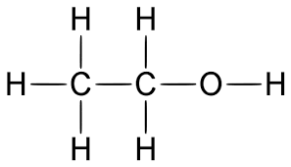

Figure 4. Ethanol structure

Below shows a table of the respective Alcohols which are used in the practical and their chemical formulas. As the amount of carbon increases so does the molar mass. (Gandhijt)

|  |  |
| --- | --- |
| Methanol | CH3OH |
| Ethanol | C2H5OH |
| N-Butanol | C4H9OH |
| Hexanol | C6H13OH |

**Aim:**

The Aim of the design practical was to investigate the relationship between the numbers of carbon atoms in alcohols such as ethanol, butanol, hexanol and methanol and their enthalpy change of combustions.

**Hypothesis:**

It can be hypothesised that the larger the amount of carbon atoms in the alcohol chain the enthalpy of combustion will become more negative.

**Variables:**

*Independent* – The different Alcohols

*Dependent* – Mass of the alcohol burnt, Temperature of the water

*Controlled variables* – Amount of distilled water, the amount of time the alcohol was burnt for.

**Apparatus and Alcohols:**

* 1 Retort Stand
* 13 Test Tubes
* Alfoil
* Water (30mL per test tube)
* 1 Thermometer
* 1 measuring cylinder
* 2 clamps
* Packet of matchsticks
* Methanol
* N-Butanol
* Hexanol
* Ethanol

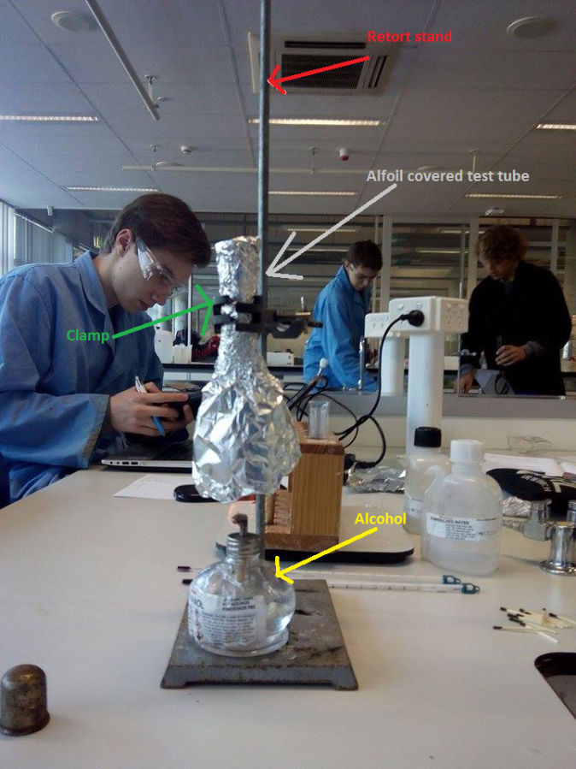**Method:**

1. 30mLs of water was measured in a measuring cylinder and placed into a test tube.
2. The test tube was then covered in alfoil in a cylindrical shape to stop excess heat not reaching the test tube.
3. The test tube was then placed on the retort stand with a clamp. The initial temperature of the water was recorded.
4. The initial weight of the alcohol hexane was recorded.
5. The Alcohol was placed under the test tube and was set alight to burn for 2 minutes using the matches.
6. Once the two minutes was up the final temperature was recorded, and the final weight of the alcohol was recorded.
7. Steps 1-6 were repeated 3 times for replicates and also for different Alcohols.

**Figure 1.** Shows the setup of the Practical

**Results:**

|  |  |  |  |  |  |  |  |
| --- | --- | --- | --- | --- | --- | --- | --- |
|  | Weight of Alcohol(g) |  |  | Water Temp(c) |  |  |  |
|  | Before | After | Difference in Weight | Before | After | Difference in temp | Molar mass |
| E1 | 291.608 | 290.295 | -1.313 | 19 | 65.5 | 46.5 | 46.06 |
| E2 | 290.295 | 288.96 | -1.335 | 19 | 64 | 45 | 46.06 |
| E3 | 288.96 | 287.628 | -1.332 | 18 | 74 | 56 | 46.06 |
| B1 | 266.872 | 266.227 | -0.645 | 18 | 50 | 32 | 74.12 |
| B2 | 266.227 | 265.551 | -0.676 | 19 | 44 | 25 | 74.12 |
| B3 | 266.551 | 264.869 | -1.682 | 18.5 | 53 | 34.5 | 74.12 |
| B4 | 264.869 | 264.218 | -0.651 | 19 | 60 | 41 | 74.12 |
| H1 | 271.731 | 271.302 | -0.429 | 18 | 45 | 27 | 102.17 |
| H2 | 271.302 | 270.814 | -0.488 | 18 | 39 | 21 | 102.17 |
| H3 | 270.814 | 270.327 | -0.487 | 18.5 | 50 | 31.5 | 102.17 |
| M1 | 250.841 | 249.415 | -1.426 | 20 | 69 | 49 | 32.04 |
| M2 | 249.415 | 247.995 | -1.42 | 19 | 65 | 46 | 32.04 |
| M3 | 247.995 | 246.464 | -1.531 | 19 | 70 | 51 | 32.04 |

Above shows the values taken from the practical. E stands for ethanol. B stands for butanol. H stands for hexanol. M stands for methanol.

**Enthalpy equations for Ethanol**

In a complete combustion when ethanol combusts it produces water and carbon dioxide.

Methanol + Oxygen 🡪 Carbon dioxide + Water

(Unbalanced) C2H6O + O2 🡪 CO2 + H2O

(Balanced) C2H6O + 3O2 🡪 2CO2 + 3H2O

Ethanol temperature change (ΔT) = 46.4, 45, 56

Mass of Ethanol burnt = -1.313, -1.335, -1.332

Molar mass of Ethanol = 46.06

Trail 1

Moles of Ethanol burnt =

=

=-0.0285 mol

Enthalpy change during combustion = *Mass of water x heat capacity of water x Temperature change*

*=mCΔt*

*=(100)x(4.182)x(46.4)*

*=19404.2 j*

*=19.404 kJ*

Standard Enthalpy of combustion of Ethanol (ΔHComb) =

=

= -680.842 kJ mol-1

Trial 2

Moles of Ethanol burnt =

=

=-0.0289 mol

Enthalpy change during combustion = *Mass of water x heat capacity of water x Temperature change*

*=mCΔt*

*=(100)x(4.182)x(56)*

*=23,419.2 j*

*=23.4192 kJ*

Standard Enthalpy of combustion of Ethanol (ΔHComb) =

=

= -810.35 kJ mol-1

Trail 3

Moles of Ethanol burnt =

=

=-0.0289 mol

Enthalpy change during combustion = *Mass of water x heat capacity of water x Temperature change*

*=mCΔt*

*=(100)x(4.182)x(45)*

*=18,810 j*

*=18.810 kJ*

Standard Enthalpy of combustion of Ethanol (ΔHComb) =

=

= -680.86 kJ mol-1

**Equations for N-Butanol**

In complete combustion when N-Butanol reacts with oxygen it produces carbon dioxide and water.

N-Butanol + Oxygen 🡪 Carbon Dioxide + Water

(Unbalanced equation) C4H9OH +CO2 🡪 CO2 + H2O

(Balanced equation) C4H9OH + 6CO2 🡪 4CO2 + 5H2O

N-Butanol temperature changes (ΔT) = 32, 25, 34.5,41

Mass of N-Butanol burnt = -0.624, -0.676, -1.682, -0.651

Molar mass of N-Butanol = 74.12

Trail 1

Moles of N-Butanol burnt =

=

=-0.00841 mol

Enthalpy change during combustion = *Mass of water x heat capacity of water x Temperature change*

*=mCΔt*

*=(100)x(4.182)x(32)*

*=13,382.4 j*

*=13.382 kJ*

Standard Enthalpy of combustion of N-Butanol (ΔHComb) =

=

= -1592.2 kJ mol-1

Trail 2

Moles of N-Butanol burnt =

=

=-0.00912 mol

Enthalpy change during combustion = *Mass of water x heat capacity of water x Temperature change*

*=mCΔt*

*=(100)x(4.182)x(25)*

*=10,455 j*

*=10.455 kJ*

Standard Enthalpy of combustion of N-Butanol (ΔHComb) =

=

= -1146.38 kJ mol-1

Trial 3

Moles of N-Butanol burnt =

=

=-0.02269 mol

Enthalpy change during combustion = *Mass of water x heat capacity of water x Temperature change*

*=mCΔt*

*=(100)x(4.182)x(34.5)*

*=14,429.9 j*

*=14.4299 kJ*

Standard Enthalpy of combustion of N-Butanol (ΔHComb) =

=

= -635.95 kJ mol-1

Trial 4

Moles of N-Butanol burnt =

=

=-0.00878 mol

Enthalpy change during combustion = *Mass of water x heat capacity of water x Temperature change*

*=mCΔt*

*=(100)x(4.182)x(41)*

*=17,147 j*

*=17.147 kJ*

Standard Enthalpy of combustion of N-Butanol (ΔHComb) =

=

= -1952.95 kJ mol-1

**Enthalpy equations for Hexanol**

In complete combustion when Hexanol reacts with oxygen it produces carbon dioxide and water.

Hexanol + Oxygen 🡪 Carbon Dioxide + Water

(unbalanced equation) C6H13OH + O2 🡪 CO2 + H20

(Balanced equation)  2C6H13OH + 18O2 🡪 12CO2 + 14H2O

Hexanol temperature changes (ΔT) = 27,31,21.5

Mass of Hexanol burnt = -0.429, -0.488, -0.487

Trial 1

Moles of Hexanol burnt =

=

=-0.00419 mol

Enthalpy change during combustion = *Mass of water x heat capacity of water x Temperature change*

*=mCΔt*

*=(100)x(4.182)x(27)*

*=11,145.6 j*

*=11.1456 kJ*

Standard Enthalpy of combustion of Hexanol (ΔHComb) =

=

= -2660.047 kJ mol-1

Trial 2

Moles of Hexanol burnt =

=

=-0.00477 mol

Enthalpy change during combustion = *Mass of water x heat capacity of water x Temperature change*

*=mCΔt*

*= (100) x (4.182) x (31)*

*=12,946.2 j*

*=12.9462 kJ*

Standard Enthalpy of combustion of Hexanol (ΔHComb) =

=

= -2652.909 kJ mol-1

Trail 3

Moles of Hexanol burnt =

=

=-0.00476 mol

Enthalpy change during combustion = *Mass of water x heat capacity of water x Temperature change*

*=mCΔt*

*= (100) x (4.182) x (21.5)*

*=8991.3 j*

*=8.9913 kJ*

Standard Enthalpy of combustion of Hexanol (ΔHComb) =

=

= -1888.92 kJ mol-1

**Enthalpy equations for Methanol**

In complete combustion when Methanol reacts with oxygen it produces carbon dioxide and water.

Methanol + Oxygen 🡪 Water + Carbon Dioxide

(Unbalanced) CH3OH + O2 🡪 H20 + CO2

(Balanced) 2CH3OH + 3O2 🡪 4H20 + 2CO2

Methanol temperature change (ΔT) = 49, 56, 51

Mass of Methanol burnt = -1.426, -1.42, -1.531

Trail 1

Moles of Methanol burnt =

=

=-0.0445 mol

Enthalpy change during combustion = *Mass of water x heat capacity of water x Temperature change*

*=mCΔt*

*= (100) x (4.182) x (49)*

*=20,491.8 j*

*=20.4918 kJ*

Standard Enthalpy of combustion of Hexanol (ΔHComb) =

=

= -460.48 kJ mol-1

Trial 2

Moles of Methanol burnt =

=

=-0.0443 mol

Enthalpy change during combustion = *Mass of water x heat capacity of water x Temperature change*

*=mCΔt*

*= (100) x (4.182) x (56)*

*=23,419.2 j*

*=23.4192 kJ*

Standard Enthalpy of combustion of Hexanol (ΔHComb) =

=

= -528.62 kJ mol-1

Trial 3

Moles of Methanol burnt =

=

=-0.0477 mol

Enthalpy change during combustion = *Mass of water x heat capacity of water x Temperature change*

*=mCΔt*

*= (100) x (4.182) x (51)*

*=21,328.2.2 j*

*=21.3282 kJ*

Standard Enthalpy of combustion of Hexanol (ΔHComb) =

=

= -447.13 kJ mol-1

All for Alcohols and their trials have been tested for combustion, below shows their average enthalpy of combustion.

|  |  |  |  |
| --- | --- | --- | --- |
| No. | Alcohol | Molar Mass | Enthalpy |
| 1 | Methanol | 32.04 | -478.74 |
| 2 | Ethanol | 46.06 | -724 |
| 3 | N-Butanol | 74.12 | -1331.87 |
| 4 | Hexanol | 102.17 | -2400.63 |

Below shows a graph of Enthalpy vs. Molar mass, note that actual values of the enthalpy are negative but cannot be graphed negatively.

The Molar mass compared to Enthalpy results show a Linear trend. The higher the molar mass the higher the combustion Enthalpy.

**Discussion:**

As seen from the graph above as the Molar mass increases so does the Enthalpy. As stated in the introduction as the number of carbon atoms increases so does the molecular chain and the molar mass increases. The alcohol (Hexanol) had the highest molar mass of 102.17 and the highest enthalpy of -2400.63. The lowest Enthalpy was Ethanol with at -478.74 with a molar mass of 32.04. Hexanol required the most amount of energy to break the bonds due to its high Molar Mass and long carbon chains, this is the reason that it had the highest Enthalpy change of -2400. The reason that Ethanol had the lowest ethanol change at -478.74 is due to the fact of its short carbon chains making it easier for its bonds to break.

The first error which would have occurred is the fact that a lot of heat wouldn’t have reached the test tube. This is an example of a systematic error. A majority of heat was lost in causing it to be the main source of error for this experiment. An improvement for this experiment would to have the experiment conducted in an environment with a more constant environment, or having an apparatus which would eliminated the heat loss of 100%.

The error which would have occurred was the misreading of the temperature. This is a source of random error. This would cause the results to show different from what they actually are because the temperature was ready incorrectly. The way that this could have been improved would to have the same person reading the temperature the whole time. Also taking the temperature reading multiple times so you are happy with a temperature.

The next error which would have occurred is heat loss through the hole at the top of the alfoil. The thermometer was placed through a hole at the top of the alfoil which could have created another place for the heat to escape. This could have been improved by putting some kind of insulator around the thermometer so there was no space for the heat to escape through the top. This was a systematic error.

Lastly the mass of the water may have not been constant throughout all of the trials. Some of the water could have evaporated off the top causing the mass to be different from other trials or inaccurately measured. This is an example of a random error. For next time the water could be kept in a cool environment and measured repeatedly to make sure it is the same amount needed.

Below shows a table of the literature values of the enthalpy of combustion of the alcohols which was used.

|  |  |  |
| --- | --- | --- |
| No | Alcohol | Enthalpy |
| 1 | Methanol | -726 |
| 2 | Ethanol | -1367 |
| 3 | N-Butanol | -2676 |
| 4 | Hexanol | -3984 |

The literature can be used to graph against the results shown from this experiment which is shown below.

Line 1 represents the Literature value and line two represents the experimental values. Just by looking at the graph we can conclude that the experimental results were similar to the literature values. By using these results, we can work out the percentage error for each alcohol.

The percentage value for Methanol can be seen below

Percentage error =

=*%34*

The percentage error for Ethanol can be seen below

Percentage error =

=*%47*

The percentage error for N-Butanol can be seen below

Percentage error =

=*%50*

The percentage error for Hexanol can be seen below

Percentage error =

=*%39*

The average percentage error for the whole experiment overall was *%42.5.*

The results showed that the enthalpy of combustion of alcohols increased linearly. The hypothesis which stated “*It can be hypothesised that the larger the amount of carbon atoms in the alcohol chain the enthalpy of combustion will become more negative*” was supported. Evidence stated that as the molecular weight increased so did the Enthalpy change. Compared to the Literature results the experimental results had an adequate precision and adequate accuracy. The percentage error for the results was 42.5% if this was slightly lower around 30% then this would have made a big different when it came to the precision and accuracy of the results. The sample size for the experiment was sufficient. There were 4 alcohols with 3 trials (with the exception of a 4th trial of N-Butanol due to an outlier result). The measuring equipment was somewhat accurate, due to the fact that it had a lot of room for human errors to occur. This experiment could have been improved if there were more alcohols to test for the enthalpy levels. Second the experiment could have been improved if it was conducted in a more temperature stable environment. Overall the results which were yielded were valid and we were able to create an adequate graph from them.

**Conclusion:**

In conclusion the design experiment was successful. The hypothesis “*It can be hypothesised that the larger the amount of carbon atoms in the alcohol chain the enthalpy of combustion will become more negative”* was supported. The results showed that as the Molecular Mass increased so did the change in Enthalpy.

**References**

Upload.wikimedia.org,. N.p., 2015. Web. 19 June 2015. (Upload.wikimedia.org)

Ausetute.com.au,. 'Chemistry Tutorial : Heat (Enthalpy) Of Combustion'. N.p., 2015. Web. 19 June 2015. (Ausetute.com.au)

Chemteam.info,. 'Chemteam: Hess' Law - Using Standard Enthalpies Of Formation'. N.p., 2015. Web. 19 June 2015. (Chemteam.info)

Gandhijt,. 'Enthalpy Of Combustion'. N.p., 2015. Web. 19 June 2015. (Gandhijt)